Metadata-Driven File Extracts in SSIS
From one config row to an outbound file with millions or billions of records, using SQL Server's own tools

Problem statement
AI is booming, and every automation request now seems to end with the question: can we use AI for this? We were asked the same about our files, first for loading them and then for producing them.
In almost all warehouse ETL work the flow is the same: structured files are loaded into staging, the data is processed and transformed, and the result is extracted for analysis and for downstream systems. Extracts sit at the end of that flow. Each one is a query plus a format: which rows, which columns, which delimiter, which file name. All of it is known in advance and can be described in a table.
So the question here is the same one: if an extract is a query and a formatting contract, why use AI to produce the file when plain code does it exactly, quickly, and at almost no cost per row?
This post shows how we automated extracts with one SSIS package driven by a config table.

The problem
The other half of an ETL platform is the outbound side: generating files from curated tables and dropping them on a landing path for clients and downstream systems. In most warehouse ETL processes the flow is the same: structured files are loaded into staging, the data is processed and transformed, and the result is extracted for analysis and for downstream systems. Because the files at both ends are structured, loading and exporting can be automated.
The traditional way is one package per extract: a source query, a Flat File Destination, and column mappings fixed at design time. Each new extract, or each added column, means a new build and deployment.
We wanted the same thing we built for loading: describe the extract in a config table, pass a name and a date, and get the file.

Why plain code and not AI
The full argument is in our companion post on file ingestion. Here is the version for extracts.
- Output must be exact. A downstream system expects dates, decimals, and NULLs in a precise format. A model that reformats or summarizes data can change values silently. A SELECT and a formatter cannot.
- Cost grows with every row. Pushing millions or billions of records through a language model means billions of tokens per run, on every run. A database engine's export utility writes the same rows for the price of the CPU and disk we already own.
- Nothing to review twice. The extract is a query. Reviewers can read it, test it, and diff it between releases.
- Data stays inside. Outbound files often contain customer data. With plain code there is no external service in the path.
AI is genuinely useful when designing the framework, drafting queries, or writing documentation. It is not needed, and it is expensive, when a deterministic program can do the work.

Architecture at a glance
Six tasks run in order:
- Execute SQL Task reads the extract's config row by name.
- Script Task builds the output file name from the pattern and date, and builds the SELECT statement.
- Execute SQL Task checks the audit table. If this extract was already produced for this date, the run stops.
- Script Task writes the file.
- Execute SQL Task writes the audit row.
- Script Task (optional) writes a small .done control file.
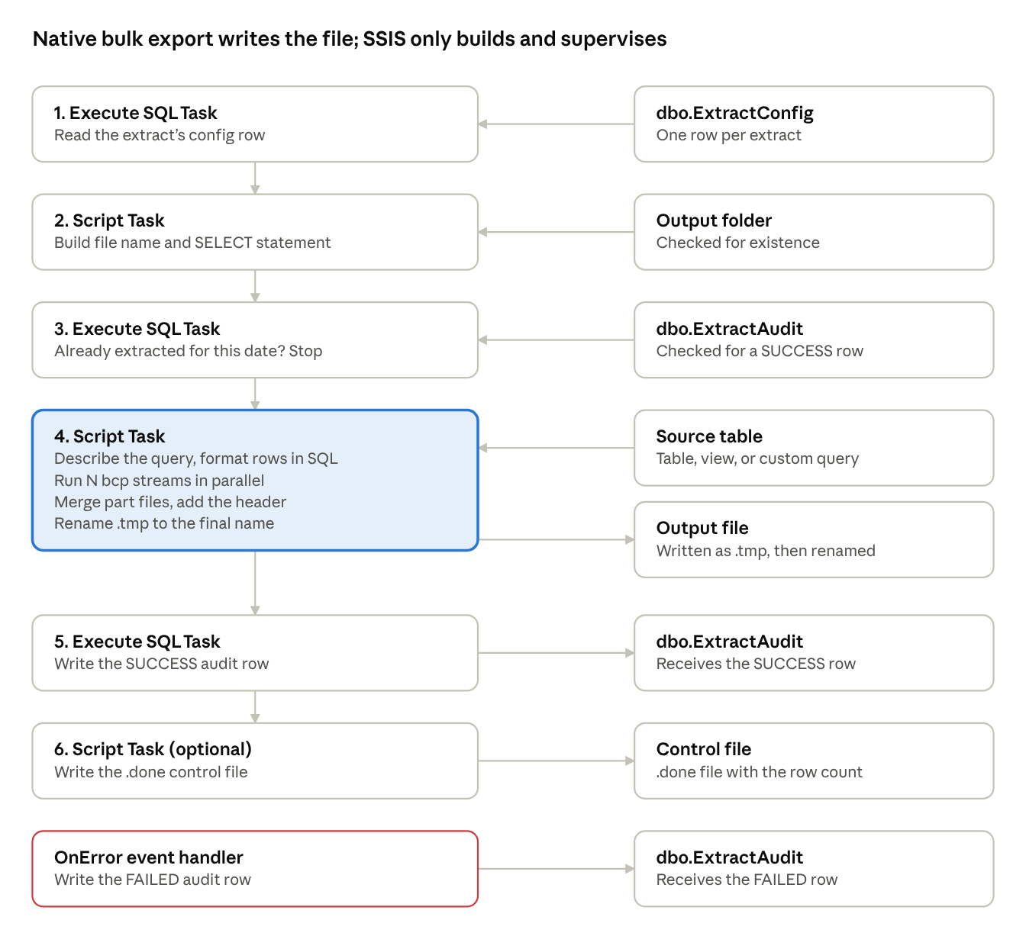
extract control flow · 6 tasks, 8 data stores
Config tells the package what to extract. Step 4, highlighted, is the only step that moves rows, and the OnError handler records any failure.
The package parameters are ExtractName and ExtractDate. As with loading, there is no Data Flow Task: its output columns are fixed at design time, while an extract's columns come from config.

The config table
CREATE TABLE dbo.ExtractConfig (
ExtractId INT IDENTITY PRIMARY KEY,
ExtractName VARCHAR(100) NOT NULL UNIQUE,
SourceSchema SYSNAME NULL,
SourceObject SYSNAME NULL, -- table or view
ColumnList VARCHAR(MAX) NULL, -- blank = all columns
DateColumn SYSNAME NULL, -- filter on ExtractDate
WhereClause VARCHAR(MAX) NULL, -- extra static filter
CustomQuery VARCHAR(MAX) NULL, -- overrides the above
Delimiter VARCHAR(10) NOT NULL DEFAULT ',',
TextQualifier CHAR(1) NULL DEFAULT '"',
IncludeHeader BIT NOT NULL DEFAULT 1,
FileEncoding VARCHAR(20) NOT NULL DEFAULT 'UTF8',
OutputPath VARCHAR(500) NOT NULL,
OutputFileNamePattern VARCHAR(200) NOT NULL, -- CUSTOMER_EXT_{yyyyMMdd}.csv
ParallelStreams INT NOT NULL DEFAULT 1,
PartitionColumn SYSNAME NULL,
CreateDoneFile BIT NOT NULL DEFAULT 0,
IsActive BIT NOT NULL DEFAULT 1
);
For example, to extract the business columns of a staging table for one load date, while leaving out housekeeping columns that start with an underscore, the config row lists the five business columns in ColumnList and names _LoadDate as the DateColumn. The package then generates:
SELECT [CustomerID], [FirstName], [LastName], [City], [Country]
FROM [stg].[Customer]
WHERE [_LoadDate] >= @ExtractDate
AND [_LoadDate] < DATEADD(DAY, 1, @ExtractDate)
The filtering column never appears in the file, because it is used only in the WHERE clause. For complex extracts, CustomQuery takes a full query that may use @ExtractDate.

Version 1: stream the rows through a data reader
Our first extract Script Task opened a data reader on the generated SELECT and wrote each row to a buffered StreamWriter, quoting fields when needed, formatting dates, and writing to a .tmp file that was renamed on success. It is short, handles any column set, and uses constant memory.
It is also the right choice for small and medium extracts. But every field of every row is read, converted, and written by one thread in managed code. Rates of a few hundred thousand rows per second are typical, which turns millions or billions of rows into a very long run. The bottleneck is our process, not the database.

Version 2: let bcp do the heavy lifting, in parallel
SQL Server ships with bcp, a native bulk export utility that writes rows to a file without row-by-row work in our code. The challenge is that bcp does not add headers, does not quote fields the way a CSV consumer expects, and cannot take parameters. We solved those with a small amount of generated SQL.
The new Script Task does five things:
- Describes the query. It runs sp_describe_first_result_set on the SELECT to get each output column's name and type, so no schema is hard-coded.
- Formats each row in SQL. It wraps the SELECT so that every row becomes one string column: text values are quoted with embedded quotes doubled, dates are converted to a fixed format, numbers to invariant text, and NULLs to empty. bcp then simply writes that one column.
- Splits the work. With ParallelStreams = 4, it starts four bcp processes. Each adds a filter such as (CHECKSUM(partition_column) & 2147483647) % 4 = k, so each stream exports a different quarter of the rows.
- Replaces the date parameter with a literal date, since bcp has no parameters.
- Assembles the file. It writes the header line, appends the part files in order, deletes them, and renames the result from .tmp to its final name. The total row count comes from bcp's own output.
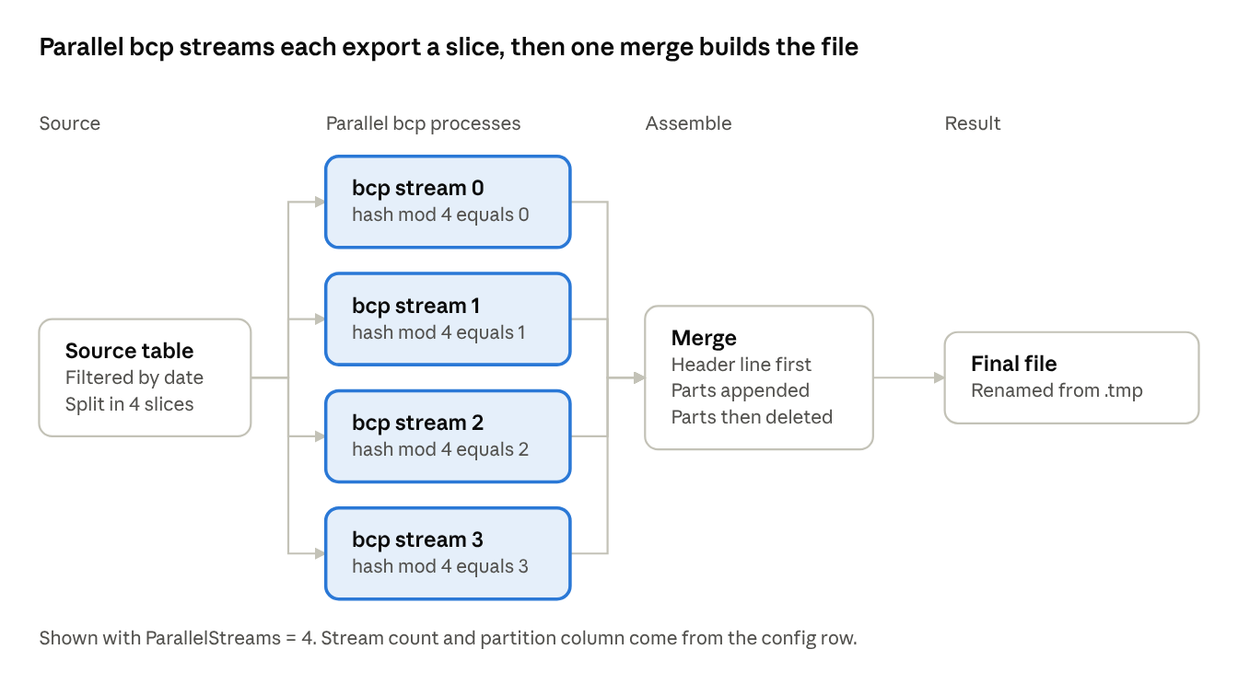
parallel bcp streams · 4 streams, 1 merge
Each stream exports its own slice of the rows. One merge step adds the header, joins the parts, and renames the result.
A per-stream query looks like this:
SELECT <one formatted string per row>
FROM (
SELECT [CustomerID], [FirstName], [LastName], [City], [Country]
FROM [stg].[Customer]
WHERE [_LoadDate] >= CONVERT(DATETIME,'20261020',112)
AND [_LoadDate] < DATEADD(DAY, 1, CONVERT(DATETIME,'20261020',112))
AND (CHECKSUM([_RowId]) & 2147483647) % 4 = 0
) AS q
The database engine reads, formats, and streams the rows. Our code only supervises the processes. Throughput is then limited by storage, network, and database CPU, and it scales with the number of streams until one of those saturates.

Safety features built in
- Temporary file and rename. The file is written as .tmp and renamed only after every stream finishes, so a downstream process never picks up a half-written file. On failure, temp files are deleted.
- Already-extracted check. The audit table is queried before any work, and a filtered unique index prevents duplicate success rows.
- Audit trail. Every run records the extract name, date, file path, row count, status, error text, and the SSISDB execution id.
- Control file. An optional .done file, containing the row count, signals to consumers that the data file is complete.
- Fail-fast config checks. A missing config row, a missing output folder, or a parallel extract without a partition column all stop the run with a clear message before any data moves.

Gotchas we hit, and how we fixed them
- bcp login failed for user. SSIS does not include the password in a connection manager's ConnectionString, so a command line built from it had a user and no password. We now read the connection string from the opened connection (the connection was created with Persist Security Info=True) and fall back to the manager's password property. Windows authentication (-T) avoids passing a password at all.
- Noise about packet size. The ODBC Driver 17 message that a packet size change is not supported is harmless once the login is correct. We simply stopped passing the packet size switch.
- Certificate errors with ODBC 18. Newer drivers require a trusted certificate by default. The -u switch (trust server certificate) goes in a configurable extra-arguments variable.
- Connection name not found. The script looks up the connection manager by its plain name. The (project) prefix in the designer is only a label.
- Config values as DBNull. The same VARCHAR(MAX) issue as in loading: cast long config columns to VARCHAR(8000) in the config query.
- Hidden errors. A default parameter value that did not match the config row's name, and an OnError handler copied from another package, produced confusing messages. Check these first when a run fails.

Advantages
- One package for every extract. A new extract is a new config row, and a new column is an edit to ColumnList.
- Scales to millions and billions of rows. Native export with parallel streams, instead of a single-threaded row loop.
- Low cost. Uses tools already licensed with SQL Server. No per-row charges.
- Exact, repeatable output. Formats are defined in code, so the same data always produces the same bytes.
- Safe delivery. Temp file plus rename, a duplicate check, an audit trail, and an optional .done file.
- Flexible. Table, view, or custom query, with any delimiter, qualifier, encoding, and file name pattern.
- Maintainable. Support teams adjust behavior through data, and developers maintain one package.

Limitations and next steps
- Row order. The file contains stream 0, then stream 1, and so on. Consumers that need a specific order need a different approach.
- Repeated scans. The modulo split makes each stream scan the table. A range split on a clustered key avoids that.
- Output formatting rules. String values are always quoted when a qualifier is set, and NULL and empty string both appear as empty.
- Final merge pass. Joining the part files rewrites the data once. If the consumer accepts multiple files, delivering the parts directly skips it.
- Credentials on the command line. The password is visible in the process list while bcp runs. Prefer Windows authentication or a dedicated low-privilege login.

Conclusion
An extract is a query plus a formatting contract. Both are deterministic, so they belong in code. By describing the extract in a config table, generating the SQL, and letting the database's own export tool write the file in parallel, we got a single package that serves every outbound feed, scales to very large volumes, and costs nothing per row to run.

